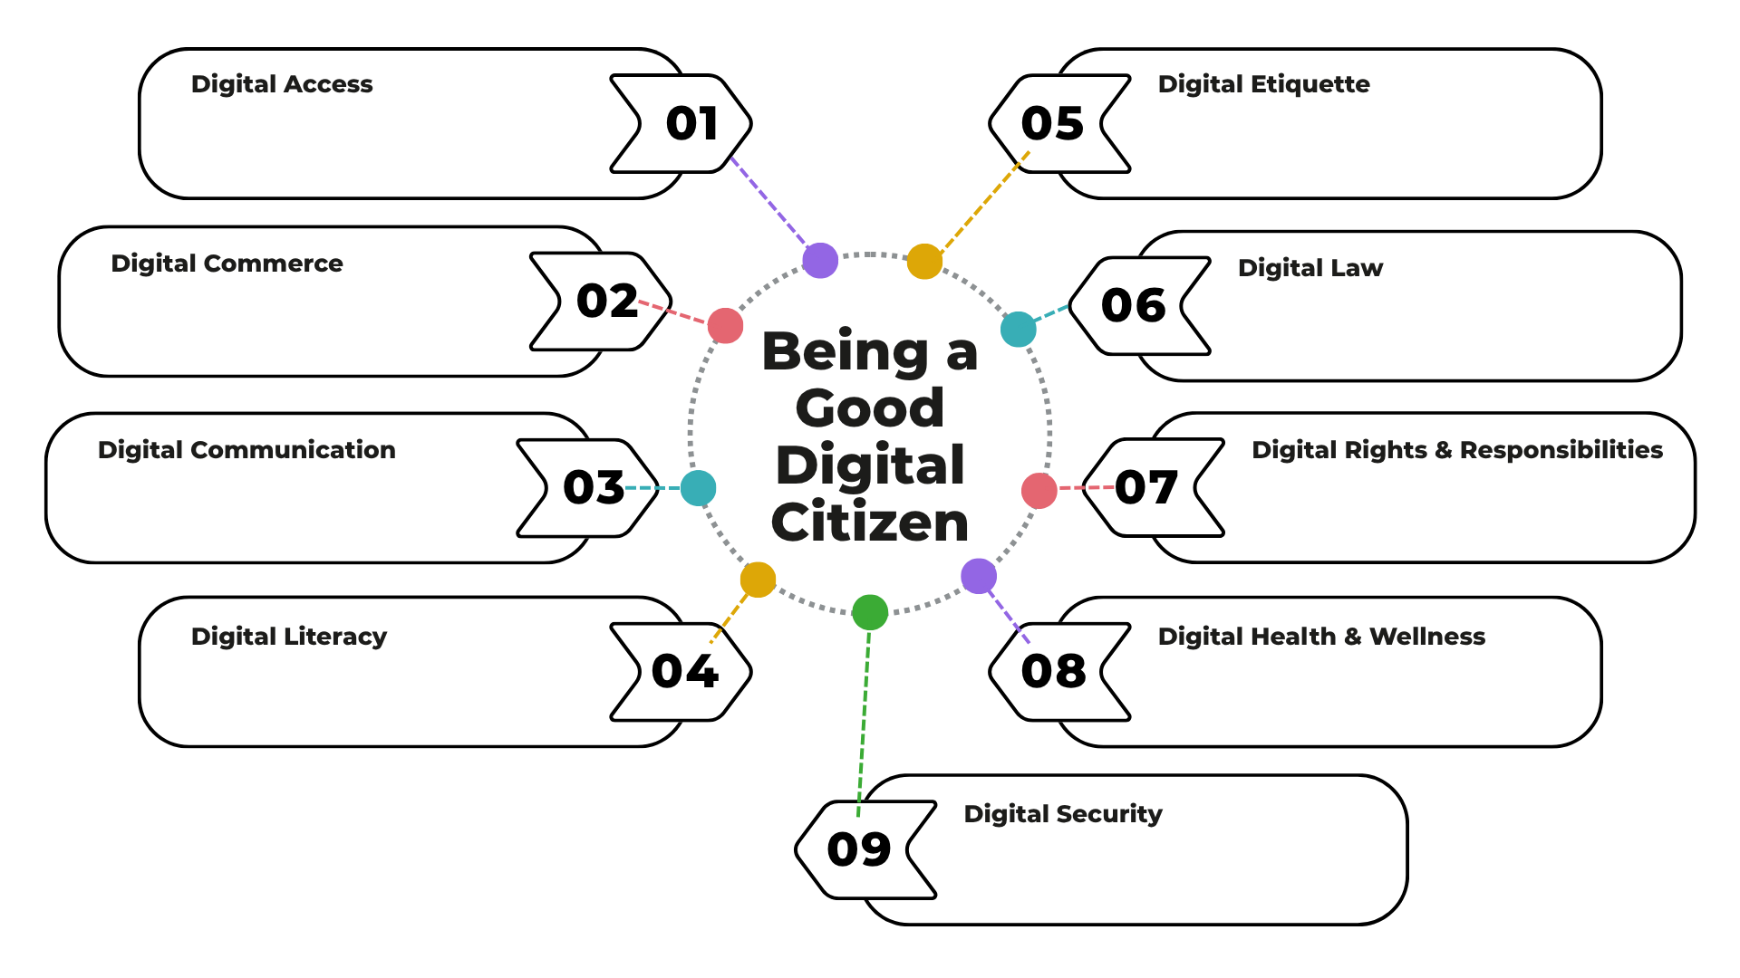
Your answer here…
Your answer here…

Your answer here…
Your answer here…

Your answer here…
Your answer here…

Your answer here…
Your answer here…

Your answer here…

Name: Section: Date:

